NovicePC.com

By Ridhwaan Ali

November 14, 2021

**Quick Recap of Plan and Overview**

**Mission Statement Purpose**: The mission and purpose for this project is to implement a website or app that targets beginner or in this case “Novice” PC builders. What is planned is there are going to be a series of hyperlinks that link to a tutorial (by me) on how to build a PC, and as well as links to specific parts of a PC. The links for the parts will feature: brief descriptions of each part, where are they usually placed using a diagram, and different sites that will redirect where to purchase these parts; specifically priced for beginner level PC builders since pricing is inflated present day. If someone has a question for the developers whether it being for a build or to improve the site, there will also be a link to email where the user can send an email.

**Impact**: This will impact society because, as seen in 2020, during the pandemic, PC building sky rocketed as seen in the demands for PC parts. Many people have wanted to or tried to build PCs during that time period, and this will be a solid guide for them to get started. This will cover fundamentals for a beginner, as well as give them a better understanding and overview on building a PC. This is also beneficial for younger generations considering technology is advancing by the day, and the younger generation have already developed an interest in building a PC.

**Possible End Results:** Novice PC builders will have a better understand the fundamentals in building a PC. They will develop the skill as well as the experience so it can be applied not just with PCs, but with various different technology; since most technology have the same concepts with their hardware structure as PCs. With this skill and experience they can also pass down the knowledge to others who also have intentions in building a PC.

**Timeline:** The plan is to record updates and progress made at the end of every week, meaning Saturday, for about three to four weeks. A few weeks will be given for testing and editing before submitting its final working version.

**Website Architecture**

**Python Codes:**

I used python as my backend language to create my website. It includes 4 different python codes: app.py (main server and main page), component.py (for the component page and links), video.py (for the video page), and part.py (for where to shop for parts page).

**HTML Codes:**

I made a total of 11 html codes: home.html, a component.html with 7 htmls containing parts, a video.html, and a part.html

**Compiler:**

I used VS code for the whole thing because installing flask on there seemed to be simpler.

**Website Map**

Home Page

Part

Video

Components

4 different places to shop for parts

Video Link

7 Different Component Pages

**Website Features and Test Run**

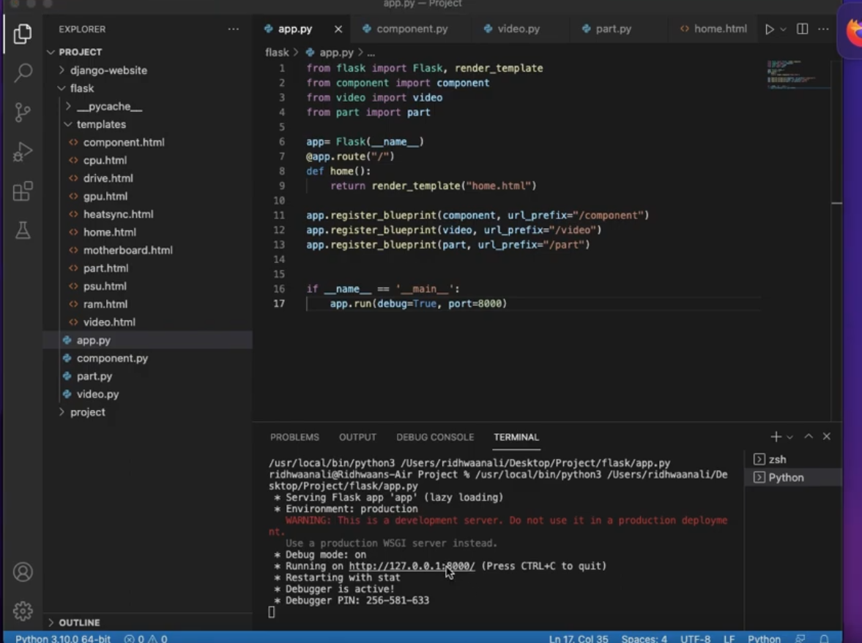

app.py executing and redirects to that ip link at port 8000

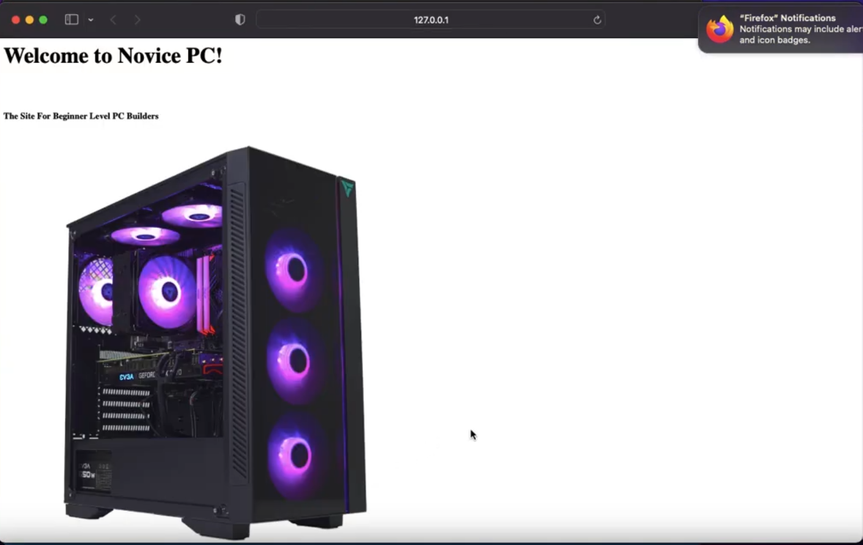

Home Page

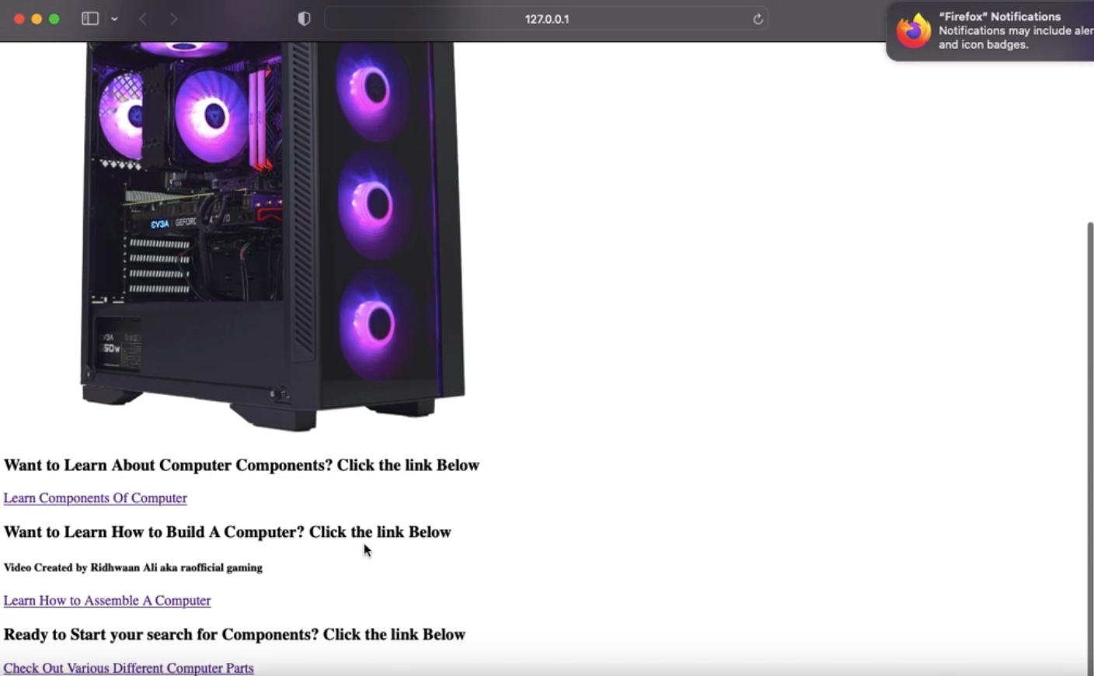

3 different links on home page that leads to components, video on how to build a pc made by me, and places where to buy computer parts

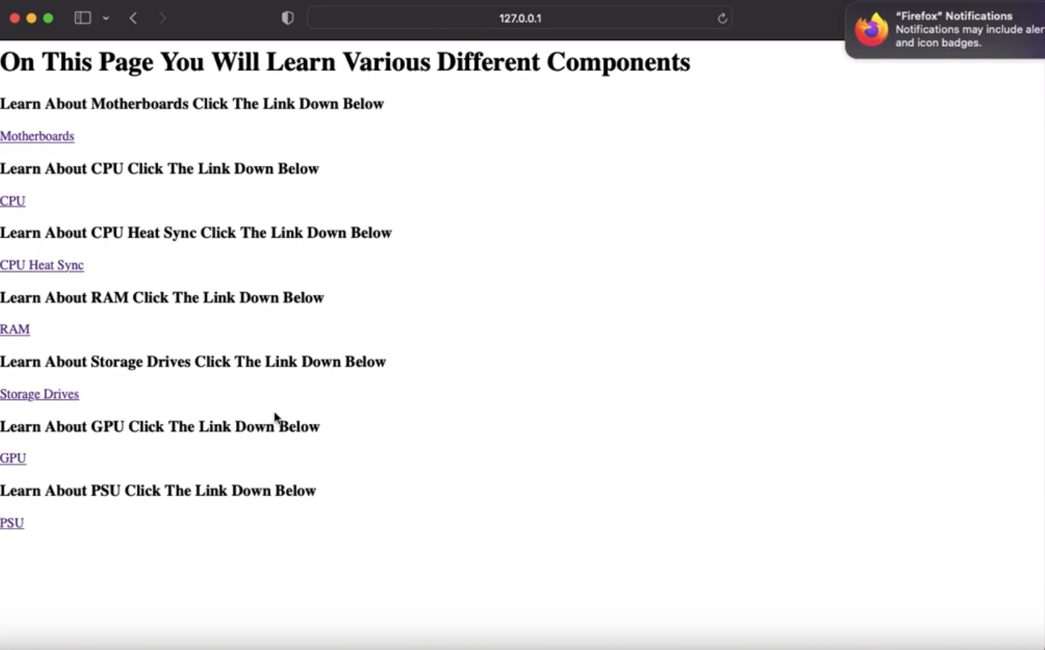

Component page with 7 different htmls I made

The following are all the Htmls from component page:

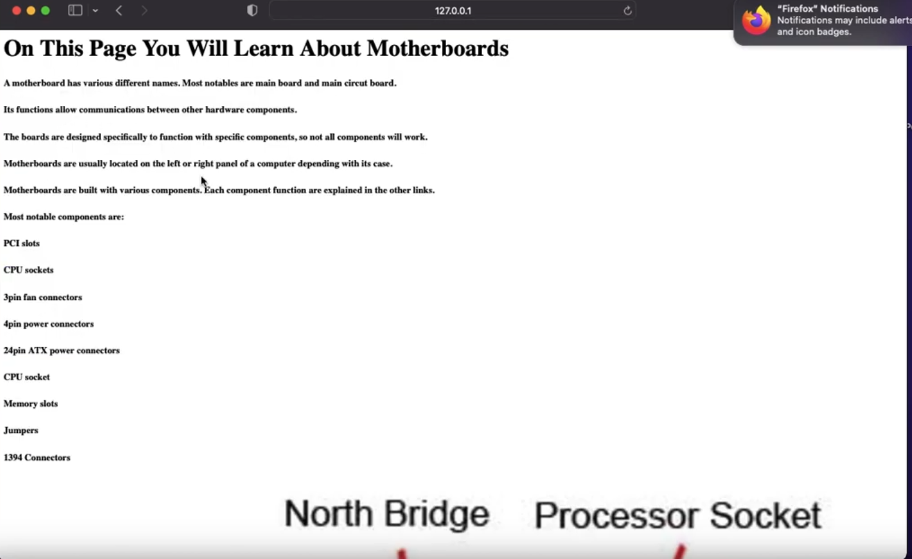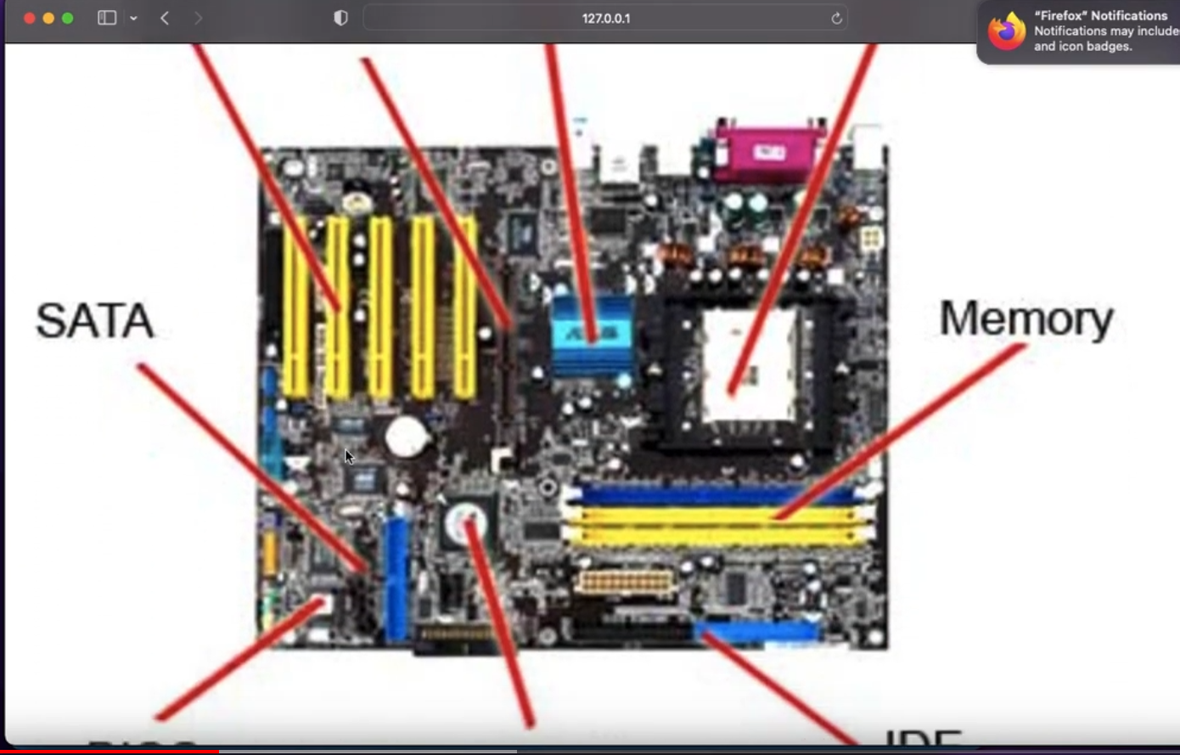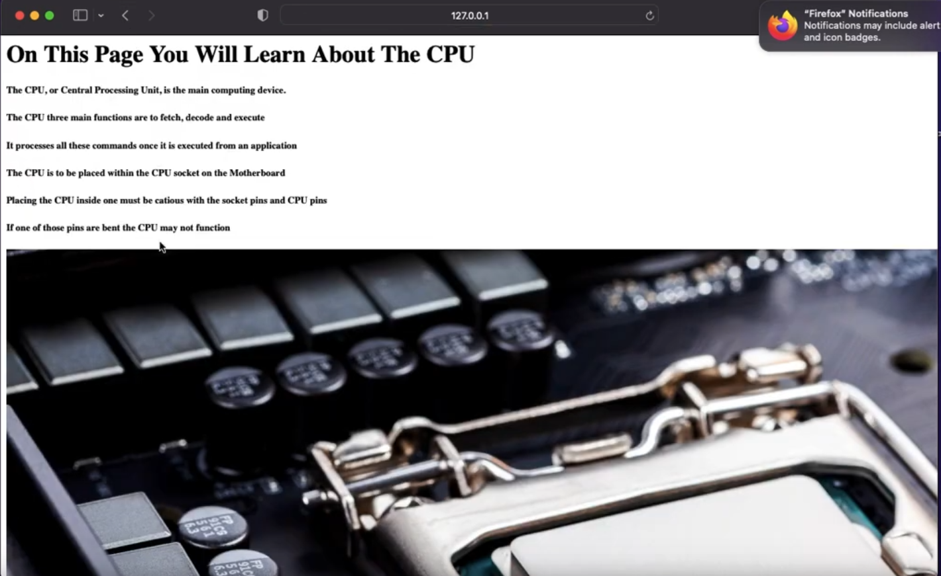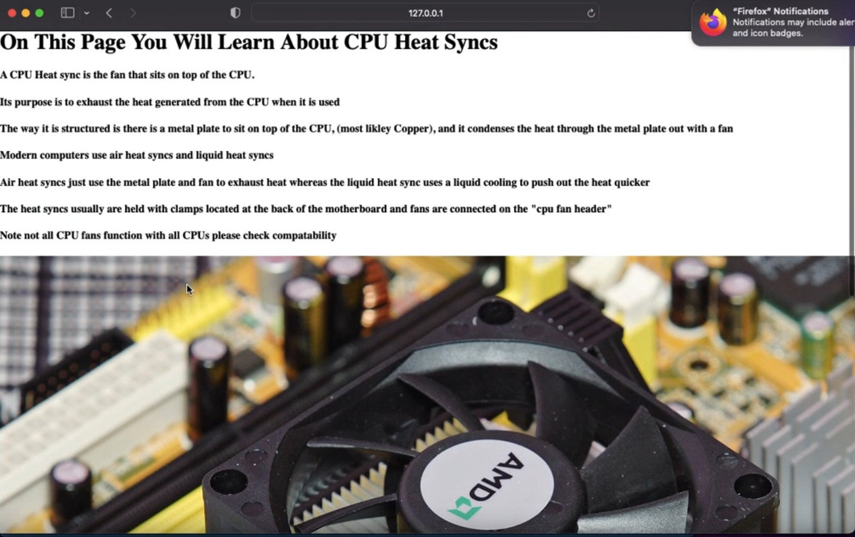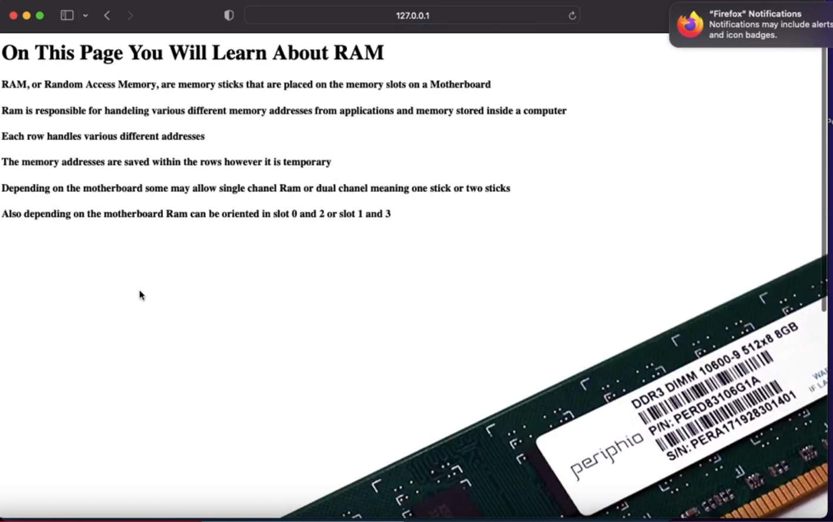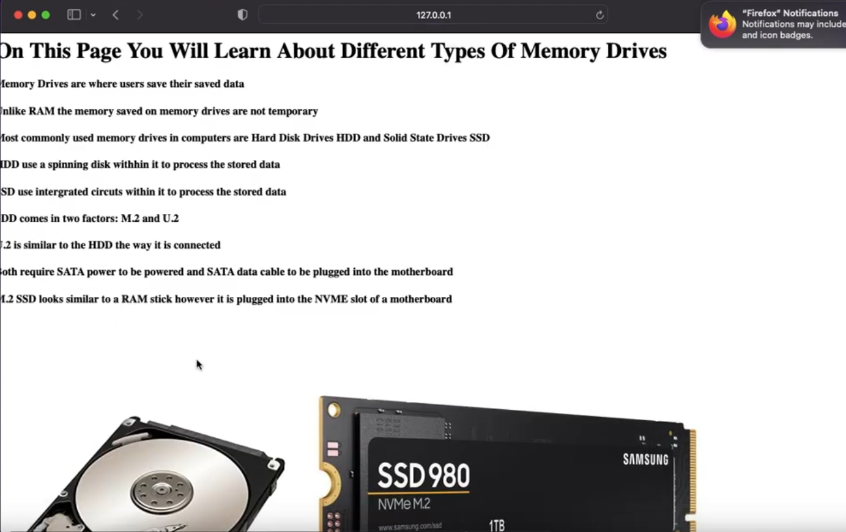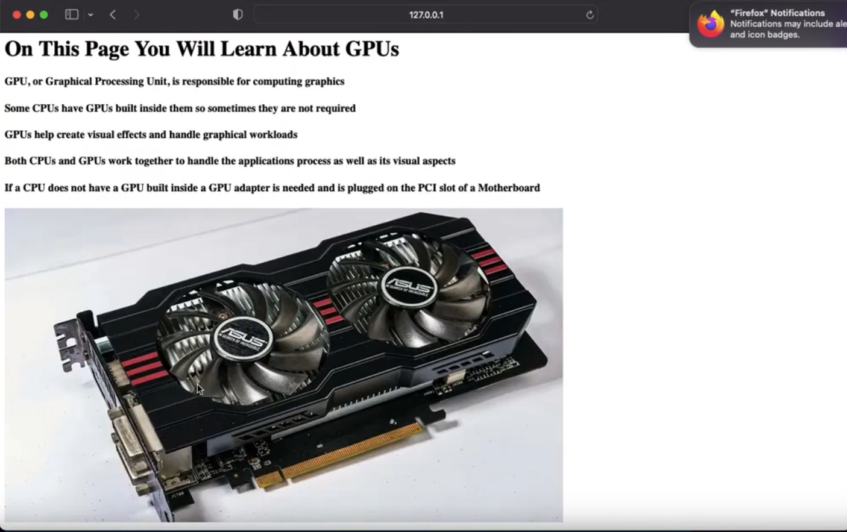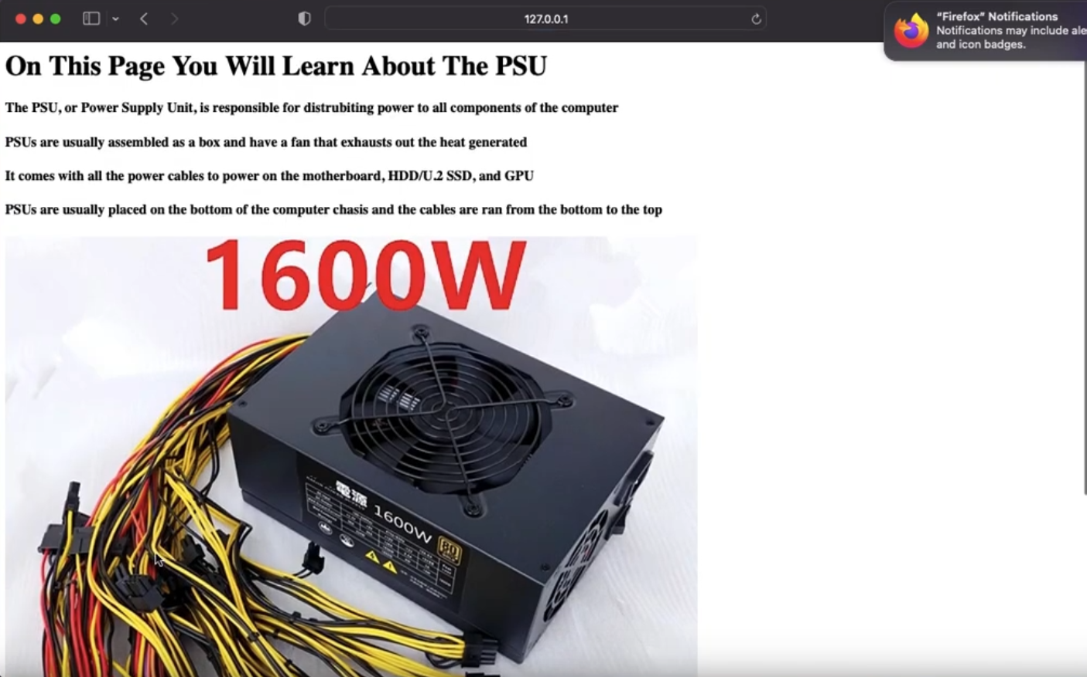

(End of Component Page)

This is the video page where it teaches the user how to build a PC

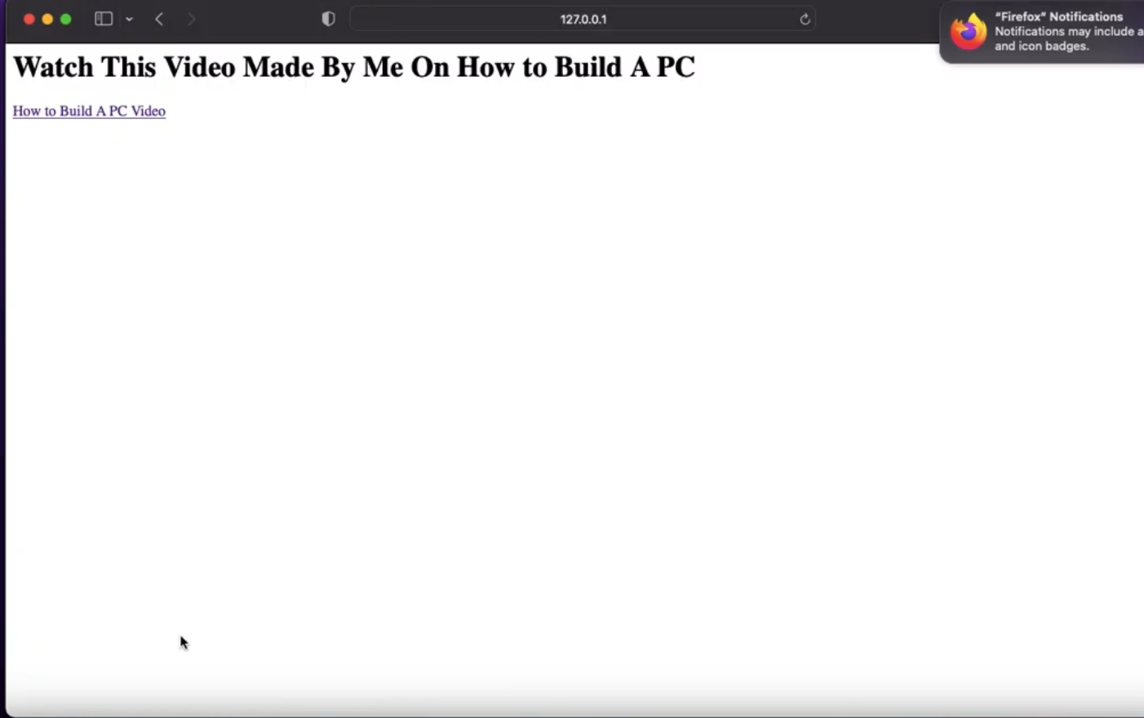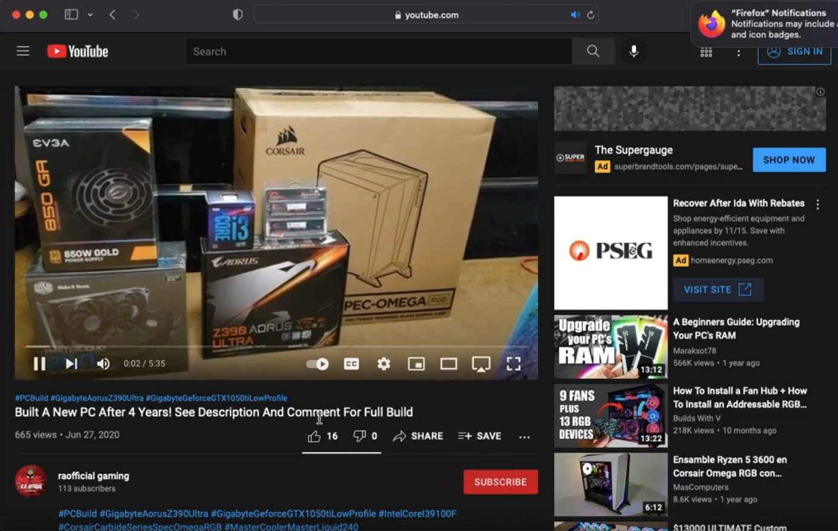

This is the actual link to the video (raofficial gaming is my gaming channel)

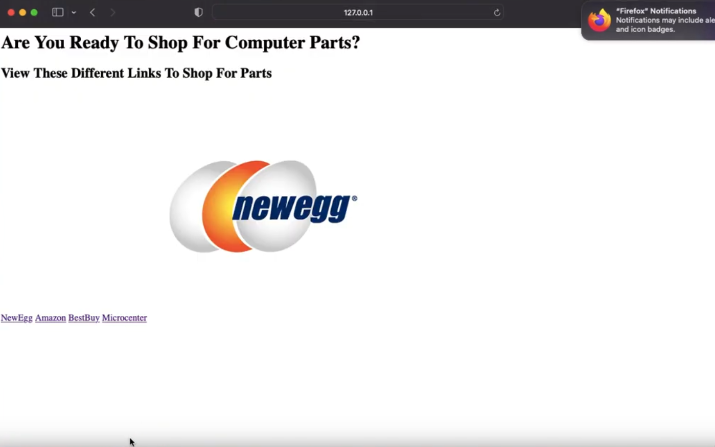

The last page of the website are 4 links where the user can find where to find PC parts.